NEWS from TLC

FOR IMMEDIATE RELEASE

TLC UNLEASHES KELL ON EARTH with a BRAND NEW REALITY SERIES
- Go behind the scenes for a look at the high-powered but exasperating world of fashion public relations with Kelly Cutrone -

Fashion might be the epitome of glamour and beauty for many but for insiders, the fashion industry is as cut-throat as it is exhilarating. Meet Kelly Cutrone, owner of People’s Revolution and public relations insider of the fashion world. The fashion industry is a battlefield for Kelly and her team as they take on a take-no-prisoners attitude when dealing with last-minute hiccups and crisis management on TLC’s brand new series KELL ON EARTH. Premieres every <day> at <time>, starting <date>. Encores <day, time>.

Kelly Cutrone is the owner of People’s Revolution, a boutique branding and public relations firm. A notable New Yorker and certainly a force to be reckoned with, the single mother lives a fast-paced, whirlwind life, juggling her business in a tough economic climate, organising major fashion shows across the world, and managing the everyday hectic pace of People’s Revolution.

Public relations reps get a bad rap but Kelly isn’t about to apologise for it anytime soon – not that her clients mind. Clad in her usual Morticia-Addams-weekend-casual look, Kelly represents clients who express a message greater than just clothing. Together with her team – Andrew Mukamal, Stefanie Skinner, Emily Bungert and Robyn Berkley – Kelly cracks the whip as they tackle fashion drama and stitch up battle-scars. KELL ON EARTH offers a revealing look into the life of one of America's most legitimate tastemakers,

Step into the well-heeled shoes of the public relations maven as she unleashes her brutal honesty and ferocious frankness to survive in the maddening world of fashion public relations. Whether you love or hate Kelly, it is hard not to admire her honesty in the air-kissing fashion industry. In the wise words of Kelly herself, “If you have to cry, go outside.”

KELL ON EARTH episode descriptions:

Walk in the Park
It is officially Mercedes Benz New York Fashion Week and People’s Revolution is busy organising upcoming shows for two of their most important clients. Kelly and her team pull off an amazing show for David Delfin, but when a computer glitch in the office creates major problems, will People’s Revolution survive this disaster or will it cost them a client and their credibility in the fashion world?

The Show Must Go On
After the mishap with client Chado Ralph Rucci, Kelly is determined to have the next show go off without a hitch, and she puts on a successful presentation for new client Genetic Denim. While Kelly is soaring, People’s Revolution employee Stephanie starts drowning in the pressures of fashion week and struggles to keep her head above water.

Highway to Kell
As Mercedes Benz New York Fashion Week comes to a close, the staff at People’s Revolution work hard to pull off one more event for designer Nicolas Petrou. When mix-ups and problems arise during this hectic time, Kelly must make a tough decision about the future of one of her employees.

Off to London
Kelly, Emily and Robyn head to London where they will help promote the 25th Anniversary of London Fashion Week. While there, the team consults with Henry Holland, head of fashion label House of Holland, and Kelly meets up with Ava’s father Illario for an emotional reunion.

Love Hangover
Kelly, Emily and Robyn are still in London and have one final show for their client Jeremy Scott. With one less Stefanie to berate, Emily takes her frustration out on the other Stefanie every chance she gets.

Skinner's Boiling Point
As Stefanie deals with her increased workload, Kelly tasks Andrew with taking on more responsibility in the office. Meanwhile, Andrew struggles to keep Robyn happy and reaches his breaking point.

Tough Times
Kelly travels to her LA bureau to gauge what is going on out west. In order to combat employee burnout, People's Revolution hires a new staff member to lessen the load around the office. Stefanie tries to find a way to juggle her boyfriend and the non-stop demands of the office.

Sunny Days
Kelly is hired for an important DKNY film and has just 24 hours to prepare it. Meanwhile, the staff decides to throw Kelly a surprise birthday party at the Carlyle Hotel, and Stefanie and Andrew fear they cannot pull it off without Big Brother Kell catching wind of it.

###

About TLC
TLC, one of the fastest-growing lifestyle channels in the United States, is a new global lifestyle channel featuring inspiring lifestyle and factual entertainment focused on travel, food, the environment, home improvement and gripping human interest stories. By first quarter of 2011, the international TLC offering will be available in more than 75 markets, reaching more than 100 million households outside the United States, making it the most widely distributed lifestyle channel brand in pay-TV. Launched in Asia Pacific on September 1, 2010, TLC is currently distributed to 133 million subscribers in the region.

About Discovery Communications
Discovery Communications (NASDAQ: DISCA, DISCB, DISCK) is the world’s number one nonfiction media company reaching more than 1.5 billion cumulative subscribers in over 180 countries. Discovery empowers people to explore their world and satisfy their curiosity through 100-plus worldwide networks, led by Discovery Channel, Animal Planet, Discovery Science and Discovery HD, as well as leading consumer and educational products and services, and a diversified portfolio of digital media services including HowStuffWorks.com. In Asia-Pacific, seven Discovery brands reach 467 million cumulative subscribers in 32 countries with programming customized in 11 languages.
BiographIES
KELL ON EARTH

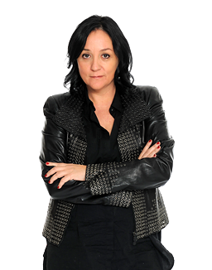
Kelly Cutrone

Founder of the powerhouse public relations firm, People’s Revolution, Kelly is a major player in the fashion world. A notable New Yorker and a force to be reckoned with, Kelly lives a fast-paced, whirlwind life juggling her business in a tough economic climate, organising major fashion shows across the world, and managing the everyday hectic pace of People’s Revolution. Somewhere in between she manages to make time for her personal life, which includes being a proud single mom to daughter Ava, and writing her first book If You Have To Cry, Go Outside.

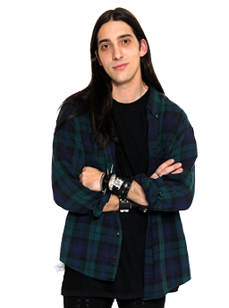
Andrew Mukamal

As Kelly’s new assistant, Andrew is a welcome addition to People’s Revolution, acting as a sounding board and ally for the other employees. While his high-end “goth” style may raise eyebrows, Andrew’s extensive knowledge and love of fashion makes him a valuable and beloved asset to Kelly and People’s Revolution. He admittedly has no long-term interest in public relations and longs to become a fashion stylist, but knows his time at People’s Revolution will be a huge stepping stone for him in the fashion world.

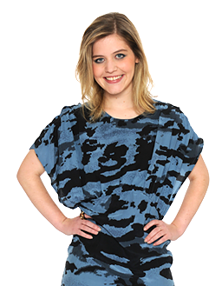
Stefanie Skinner

Stefanie is Kelly’s former assistant and has recently been promoted to Junior Executive. Having quit People’s Revolution once due to the long hours and the non-stop pace, Stefanie is back and has become one of Kelly’s most beloved employees. Struggling to balance her personal life with her work life is one of Stefanie’s major conflicts, but her dedication to her job shines through in the most hectic of times.

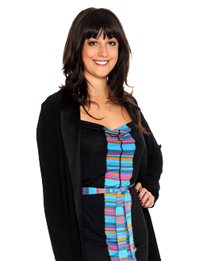
Emily Bungert

A true power publicist and a partner at People’s Revolution, Emily meticulously helps steer the company towards excellence. She has a blunt and assertive approach to work, but her no-holds-barred attitude sometimes puts her at odds with the other staff members. Emily has recently assumed the guillotine lead from Kelly - leaving her to be the head of the firing squad this season. Emily is an unapologetic toughie with the heart of a hometown Minnesota girl.

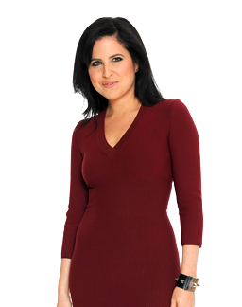
Robyn Berkley

A partner at People’s Revolution, she is the heartbeat of the agency. Kelly refers to her lovingly and jokingly as her wife or sister. Robyn is a break-out star in the industry and holds the business up as Kelly pioneers the next plateau. Robyn didn’t even have enough time to find a new apartment so she took refuge on the fifth floor of People’s Revolution where Kelly waits to hear her footsteps in the morning before another crazy day ensues. Robyn’s sweet exterior combined with her penchant for perfection and intolerance for excuses has earned her the nickname – Snow White with Razor Blades.

###

