
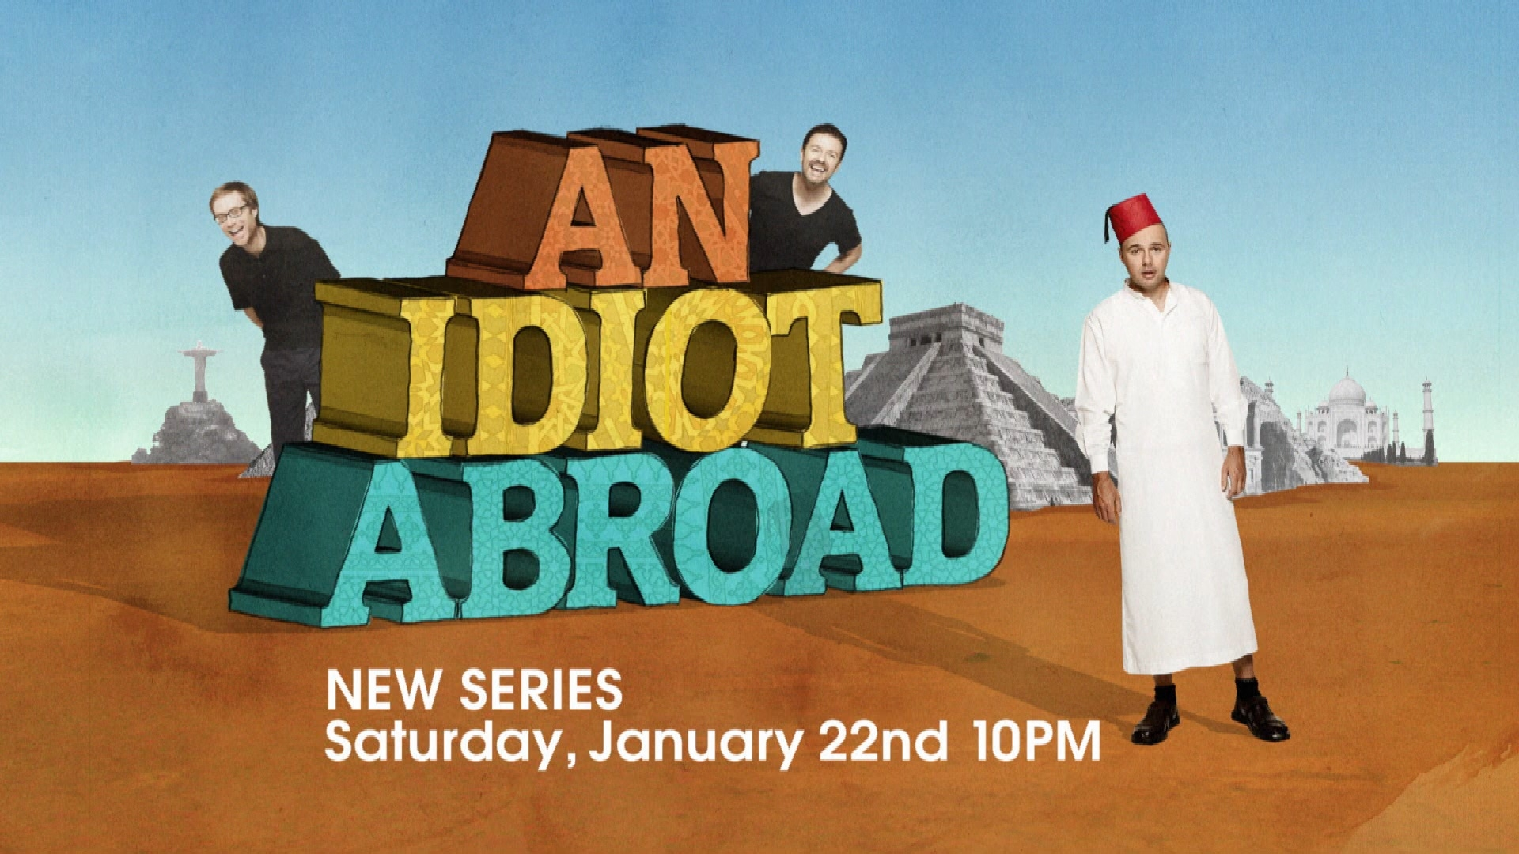

AN IDIOT ABROAD
Biographies
Ricky Gervais
At the turn of this century Ricky was preparing to star and direct a pilot he had written with Stephan Merchant for the BBC, called “The Office”. It went quite well and a series was commissioned. It first aired at 9.30pm on Monday July 9, 2001 on the BBC. The rest, as they say, is history.
It is the most critically acclaimed sitcom of all time becoming the first British comedy to win a Golden Globe. In all, Ricky has won three Golden Globes, two Primetime Emmys, and seven BAFTAS. ‘The Office’ is the most successful British comedy of all time being shown in over 90 countries with seven remakes. The NBC version is the most successful US remake of a British show for over 30 years. It reached the magic 100 episodes in 2009 and has started its first phase of syndication.
Ricky won his first Emmy as Executive Producer on ‘The Office’(US) in 2006. He won his second for ‘Extras’ in 2007. Only two British sitcoms have won Golden Globes – ‘The Office’ and ‘Extras’.
Over a 10-year period Ricky Gervais has become the most influential British comedian since Charlie Chaplin. He is an award-winning stand up comedian and his tour “Fame” became the fastest selling UK stand up show in history selling an untouchable 100,000 tickets in 9 minutes! He performed to 500,000 People that year including his first US tour, which was recorded as an HBO Special at Madison Square Garden. The show received three Emmy nominations. His latest tour has sold nearly a million tickets worldwide and his second HBO special premiered on Dec. 18th, 2010
He is the only guest star of The Simpsons to also write an episode. It became the highest rated Simpson’s episode of all time on Sky One in 2006. He also appeared on Sesame Street, which he claims is the highlight of his career.
In 2005 Ricky turned his hand to podcasting and is now in the Guinness Book of World Records for having the most downloaded internet show of all time. He was the first to charge for podcasts the following year and has now clocked up a staggering 250,000,000 shows downloaded. ‘The Ricky Gervais Show’ has been the number one selling audio book in the world since 2006. In 2009 it was made into the 13-part animated series for HBO with Season 2 to air in January 2011.
He started his year in January 2010 as the first host of the Golden Globes since 995 and will continue the role in 2011. He was named in Time Magazine’s ‘100 Most Influential People In The World’, and awarded the ‘Sir Peter Ustinov Comedy Award’ from the Banff World Television Festival.
Stephen Merchant
Stephen Merchant was born in Bristol in 1974 and began his career as a stand-up comedian and radio presenter.
As co-creator, co-writer and co-director of “The Office,” he’s won numerous awards, including three BAFTAS and three British Comedy Awards. "The Office" was the first UK sitcom ever to win a Golden Globe award, and Merchant also won an Emmy as Executive Producer of the US version of "The Office".
Following the success of “The Office,” Merchant, with partner Ricky Gervais, went on to co-create, co-write, co-direct and co-star in two seasons of the hilarious industry satire “Extras,” for BBC and HBO. Merchant won another Golden Globe for "Extras" as well as the Best Actor award at the 2006 British Comedy Awards.
His film credits include the forthcoming Owen Wilson comedy "Hall Pass", "Tooth Fairy" with Dwayne Johnson and cameos in “Hot Fuzz” and “Run Fat Boy Run" alongside Simon Pegg.
Merchant, along with Gervais and Karl Pilkington, entered the Guinness Book of World Records thanks to their hugely popular podcasts, which have notched up over eight million downloads. Their conversations have subsequently been animated for a HBO cartoon series "The Ricky Gervais Show".
Merchant was executive producer on "An Idiot Abroad", a live-action travelogue series starring Karl Pilkington which broke ratings records when screened in the UK,
He recently collaborated again with Gervais, co-writing and co-directing their first feature film, Cemetery Junction, which was released in Spring 2010.
Karl Pilkington
Karl Pilkington was born in 1972 and grew up on a council estate in Manchester. A myriad of unfortunate family incidents contributed to an unconventional upbringing.
His brother was thrown out of the army for driving to the shops in a tank to buy a packet of cigarettes, his uncle slept in a rubber dinghy instead of a bed; and his teachers told him that he would never be a high flyer. He, on the other hand, believed they were profiting from his education and filling his days with menial and pointless tasks, like attaching as many stickers to a Thomson brochure as possible in 30 minutes. Karl disliked school.
Karl also had a number of near-death experiences as a child. He nearly choked to death on a freeze-pop, almost plummeted to the ground when climbing out of an upstairs window to do his paper round (it was blizzard conditions and Karl's mom had locked the door to stop him going out in such dangerous conditions) and then there was the 'bad cream incident', when he ate far too many doughnuts that had been thrown out the back of a local baker's shop.
Karl survived into adulthood and after leaving school without his exam results. (He got an ‘E’ in History - as Ricky Gervais revealed live on the radio- although Karl can’t actually recall taking the exam). He went through several jobs and eventually found gainful employment as a producer at the radio station XFM. But he didn’t stay off-air for long, and his antics and opinions coupled with his fascination for odd stuff, distrust of animals, and dislike of crowds, meant that he quickly became an unintentional star of the show and a cult hero. High praise indeed came from Ricky himself, who proclaimed Karl to be "the funniest man alive in Britain today".
A series of world record-breaking podcasts with Ricky Gervais and Stephen Merchant followed. ‘The Ricky Gervais Show’ made Karl Pilkington a household name around the world and he’s even had his face printed onto a garage door in Augusta, Georgia. The podcasts went to #1 in 14 countries - including America - and have remained at the top of the charts for over two years. The Ricky Gervais Show has been downloaded 250 million times. The American cable TV channel HBO has made an award winning animated series using the original recordings. Karl has also written three books.
After a decade as a radio producer, Karl left XFM, taking with him a digital camera, which was his leaving gift and is now his girlfriend’s after he gave it to her for a Christmas present.

