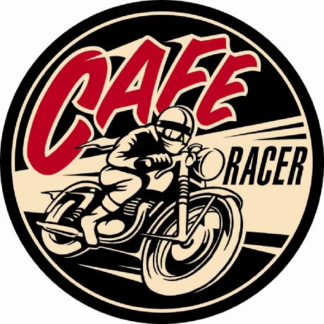

FOR IMMEDIATE RELEASE CONTACT: Brittany Whiteford: 240.662.6089
March XX, 2012 Brittany_Whiteford@discovery.com
-OR - Joanne Schioppi: 212.548.5084
Joanne_Schioppi@discovery.com
REBELS, ROCKERS AND RENEGADES RIDE AGAIN ON AN ALL NEW SEASON OF CAFÉ RACER ON VELOCITY
-- Motorcycle Maestro, Mike Seate, Hosts All-New Episodes Premiering April 19 at 8:00 PM --
(Silver Spring, Md.) – There’s no other feeling comparable to hitting 100 mph on a café racer. The signature rumble of the engine, the indelible smell of burning rubber, and the unmatched heritage of “cool” have made this two-wheeled subculture the home for Hollywood stars, barnyard builders, and thrill seekers worldwide. Velocity takes viewers inside this underground society with the return of the fan-favorite franchise that conquers the need for speed. Hosted by motorcycle aficionado, Mike Seate, CAFÉ RACER promises an exclusive look at the culture and craft behind these storied bikes. The new season of CAFÉ RACER premieres on Velocity Thursday, April 19 at 8:00 PM (ET/PT), followed by a special bonus premiere episode at 8:30PM (ET/PT).
Now in its third season, CAFÉ RACER hosts a trip into the rich cultural past, present, and future of the café scene. In perhaps the most influential motorcycle movement in history, café racers emerged in post-WWII Britain, from a group of disenchanted youth. Café racer culture still thrives around the globe as motorcycles are made over to fit the look and feel of the original bikes. These rides are often stripped of excess parts, and their engines tuned for maximum speed, in order to achieve the Holy Grail of café racing: hitting the 100-mph mark, or “Doing the Ton”.
“CAFÉ RACER has become a key franchise for Velocity,” said Bob Scanlon EVP of the network. “The show delivers on our promise to give viewers exclusive access to their favorite experts and take them on rides they’ve never had before.”
“Where choppers are more about show than go, café racers are all about speed. The ability to build and ride a hand-made, high-performance motorcycle has kept café racers popular for over 60 years,” said Mike Seate, host and coordinating producer.
In the seasons premiere episode, CAFÉ RACER visits the legendary NCR Ducati shop in Italy to acquire exclusive parts for a one-of-a-kind build. Future episodes will include a Bostrom Brothers’ surprise build; lighting fast tests at Little Talledega; a controversial custom build that that will exceed six figures; and, an exclusive look into the Cretins, America’s first café racing society.
For more information on Velocity, please visit Velocity.com, on Facebook at http://www.facebook.com/VelocityTV or on Twitter @VelocityTV1
CAFÉ RACER is produced for Velocity by Chet Burks Production. For Velocity, Dave Lee is executive producer and Shaan Akbar is associate producer. For Chet Burks Productions, Chet Burks is Executive Producer and Ed Coughlin is Sr. Show Producer.

About Velocity: Velocity, a division of Discovery Communications, Inc. (Nasdaq: DISCA, DISCB, DISCK), is the upscale men’s cable network that provides high-octane programming for its viewers. Velocity programming is diverse, intelligent and engaging, with series and specials representing the best of the automotive, sports and leisure, adventure and travel genres. Formerly HD Theater, the fully HD network is available in approximately 40 million homes. For more information on Velocity, please visit Velocity.tv, on Facebook at facebook.com/VelocityTV or on Twitter @VelocityTV1
About Discovery Communications: Discovery Communications (Nasdaq: DISCA, DISCB, DISCK) is the world's #1 nonfiction media company reaching more than 1.5 billion cumulative subscribers in 210 countries and territories. Discovery is dedicated to satisfying curiosity through 142 worldwide television networks, led by Discovery Channel, TLC, Animal Planet, Science and Investigation Discovery, as well as U.S. joint venture networks OWN: Oprah Winfrey Network, The Hub and 3net, the first 24-hour 3D network. Discovery also is a leading provider of educational products and services to schools and owns and operates a diversified portfolio of digital media services, including HowStuffWorks.com. For more information, please visit www.discoverycommunications.com.

