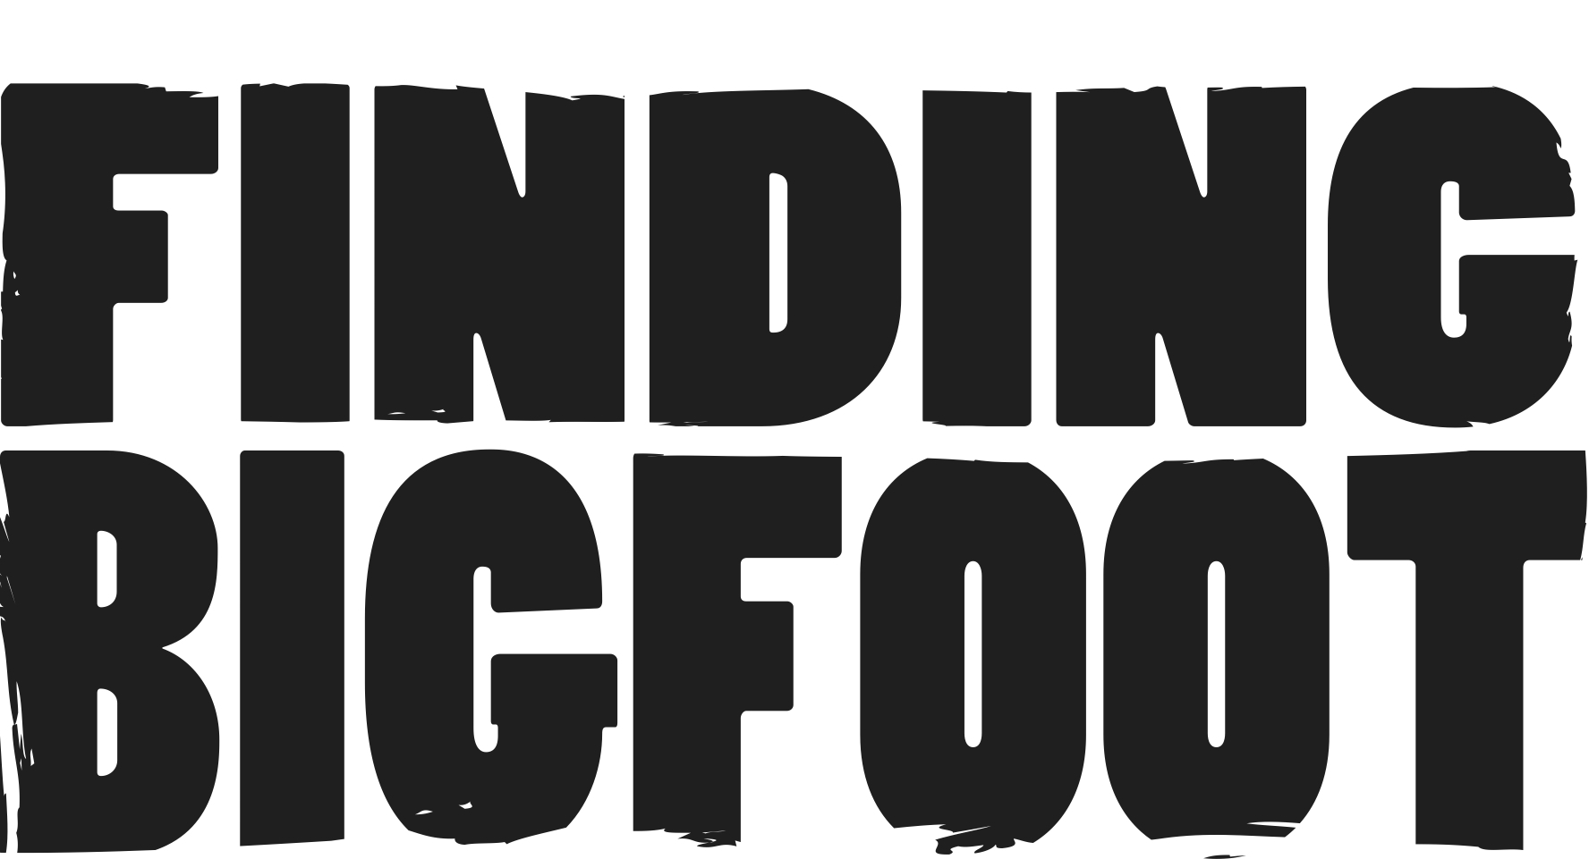
James “Bobo” Fay, Bigfoot Researcher
James Fay, or Bobo, was born and raised in the south bay of Los Angeles, California and has been interested in Bigfoot for as long as he can remember. In junior high school, Bobo became an avid surfer, a skill he would eventually combine with his love of squatching to surf into remote Bigfoot locations along the pacific North West.
Bobo attended Humboldt State University in the late 1980's, allowing him to explore nearby Bigfoot hotspots including the infamous Bluff Creek and Willow Creek areas. In 1989, Bobo recorded the first of multiple Bigfoot sightings, but it was this initial sighting that increased his passion for Bigfoot the most.
Following college, Bobo took multiple jobs that put him in Squatchy areas. Among these jobs was a logging gig with Native American crews which led to an increase in his knowledge of the Sasquatch. During the winter months, Bobo would commercially fish crabs, a job that allowed him ample down time during the prime squatching season.
Today, Bobo continues to fish commercially out of his home port of Eureka, California, but he also runs a fire-prevention brush removal service that takes him into remote mountain properties in the heart of Bigfoot country. Bobo’s close relationship with his local community allows him to collect hundreds of Sasquatch sightings each year.

