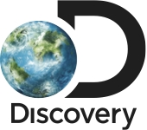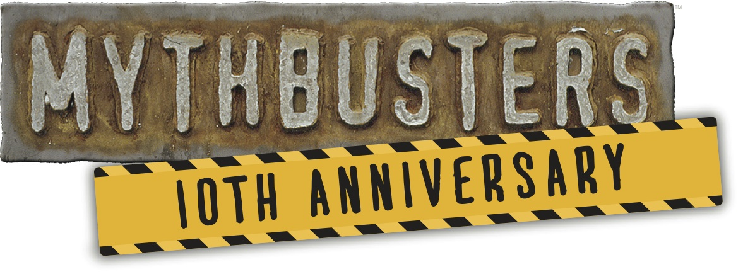

FOR IMMEDIATE RELEASE CONTACT:
April 3, 2013 Sean Martin, 212-548-5892
Sean_Martin@discovery.com
Kate Aconfora, 310-975-5902
Kate_Aconfora@discovery.com

MYTHBUSTERS CELEBRATES 10 YEAR ANNIVERSARY WITH ALL-NEW EPISODES BEGINNING WEDNESDAY, MAY 1

(New York, NY) Starting May 1 at_9pm ET/PT, MYTHBUSTERS kicks off all-new episodes by revisiting the first myth that was ever tested 10 years ago and finding out if a rocket-propelled car can actually fly. Other highlights this season include a BREAKING BAD crossover episode, an epic collaboration with the DEADLIEST CATCH captains and an episode featuring Indycar driver Ryan Briscoe and Olympic runner Wallace Spearmon. MYTHBUSTERS, which kicked off on Discovery Channel in 2003, is hosted by Jamie Hyneman and Adam Savage, along with Tory Belleci, Kari Byron and Grant Imahara. Inspiring a generation to inquire, interact and get involved with science, MYTHBUSTERS uses a signature brand of explosive experimentation to prove or disprove popular myths, misconceptions or legends. Over the past 10 years, the team has tested 885 myths, filmed over 7200 hours, created 815 explosions and used 43,500 yards of duct tape.

Additional Spring 2013 myths will include:
- Can power naps taken over a 30-hour period double your performance as opposed to staying away for 30 hours straight?
- Is a crab pot really indestructible like the DEADLIEST CATCH captains claim it is?
- Which is more sanitary: drying your hands with a hand dryer or a hand towel?
- What is the best way to protect yourself during an earthquake?
- Is it actually possible that Indy racing drivers sweat so much that they can lose 10 pounds of body mass per race?
- Are women better than men at multitasking?
- Can you really use explosives to help paint a room?

MYTHBUSTERS links:
FAN SITE: http://discovery.com/mythbusters
FACEBOOK: http://facebook.com/mythbusters
TWITTER: @mythbusters
PRESS INFO: http://press.discovery.com/us/dsc/programs/mythbusters/

About Discovery Channel
Discovery Channel is dedicated to creating the highest quality non-fiction content that informs and entertains its consumers about the world in all its wonder, diversity and amazement. The network, which is distributed to 100.1 million U.S. homes, can be seen in over 180 countries, offering a signature mix of compelling, high-end production values and vivid cinematography across genres including, science and technology, exploration, adventure, history and in-depth, behind-the-scenes glimpses at the people, places and organizations that shape and share our world. For more information, please visitwww.discovery.com.

About Discovery Communications
Discovery Communications (Nasdaq: DISCA, DISCB, DISCK) is the world's #1 nonfiction media company reaching more than 1.8 billion cumulative subscribers in 209 countries -more- and territories. Discovery is dedicated to satisfying curiosity through 149 worldwide television networks, led by Discovery Channel, TLC, Animal Planet, Science and Investigation Discovery, as well as US joint venture networks OWN: Oprah Winfrey Network, The Hub and 3net, the first 24-hour 3D network. Discovery also is a leading provider of educational products and services to schools and owns and operates a diversified portfolio of digital media services, including Revision3. For more information, please visit www.discoverycommunications.com.

###
For photography and additional information, visit press.discovery.com.

