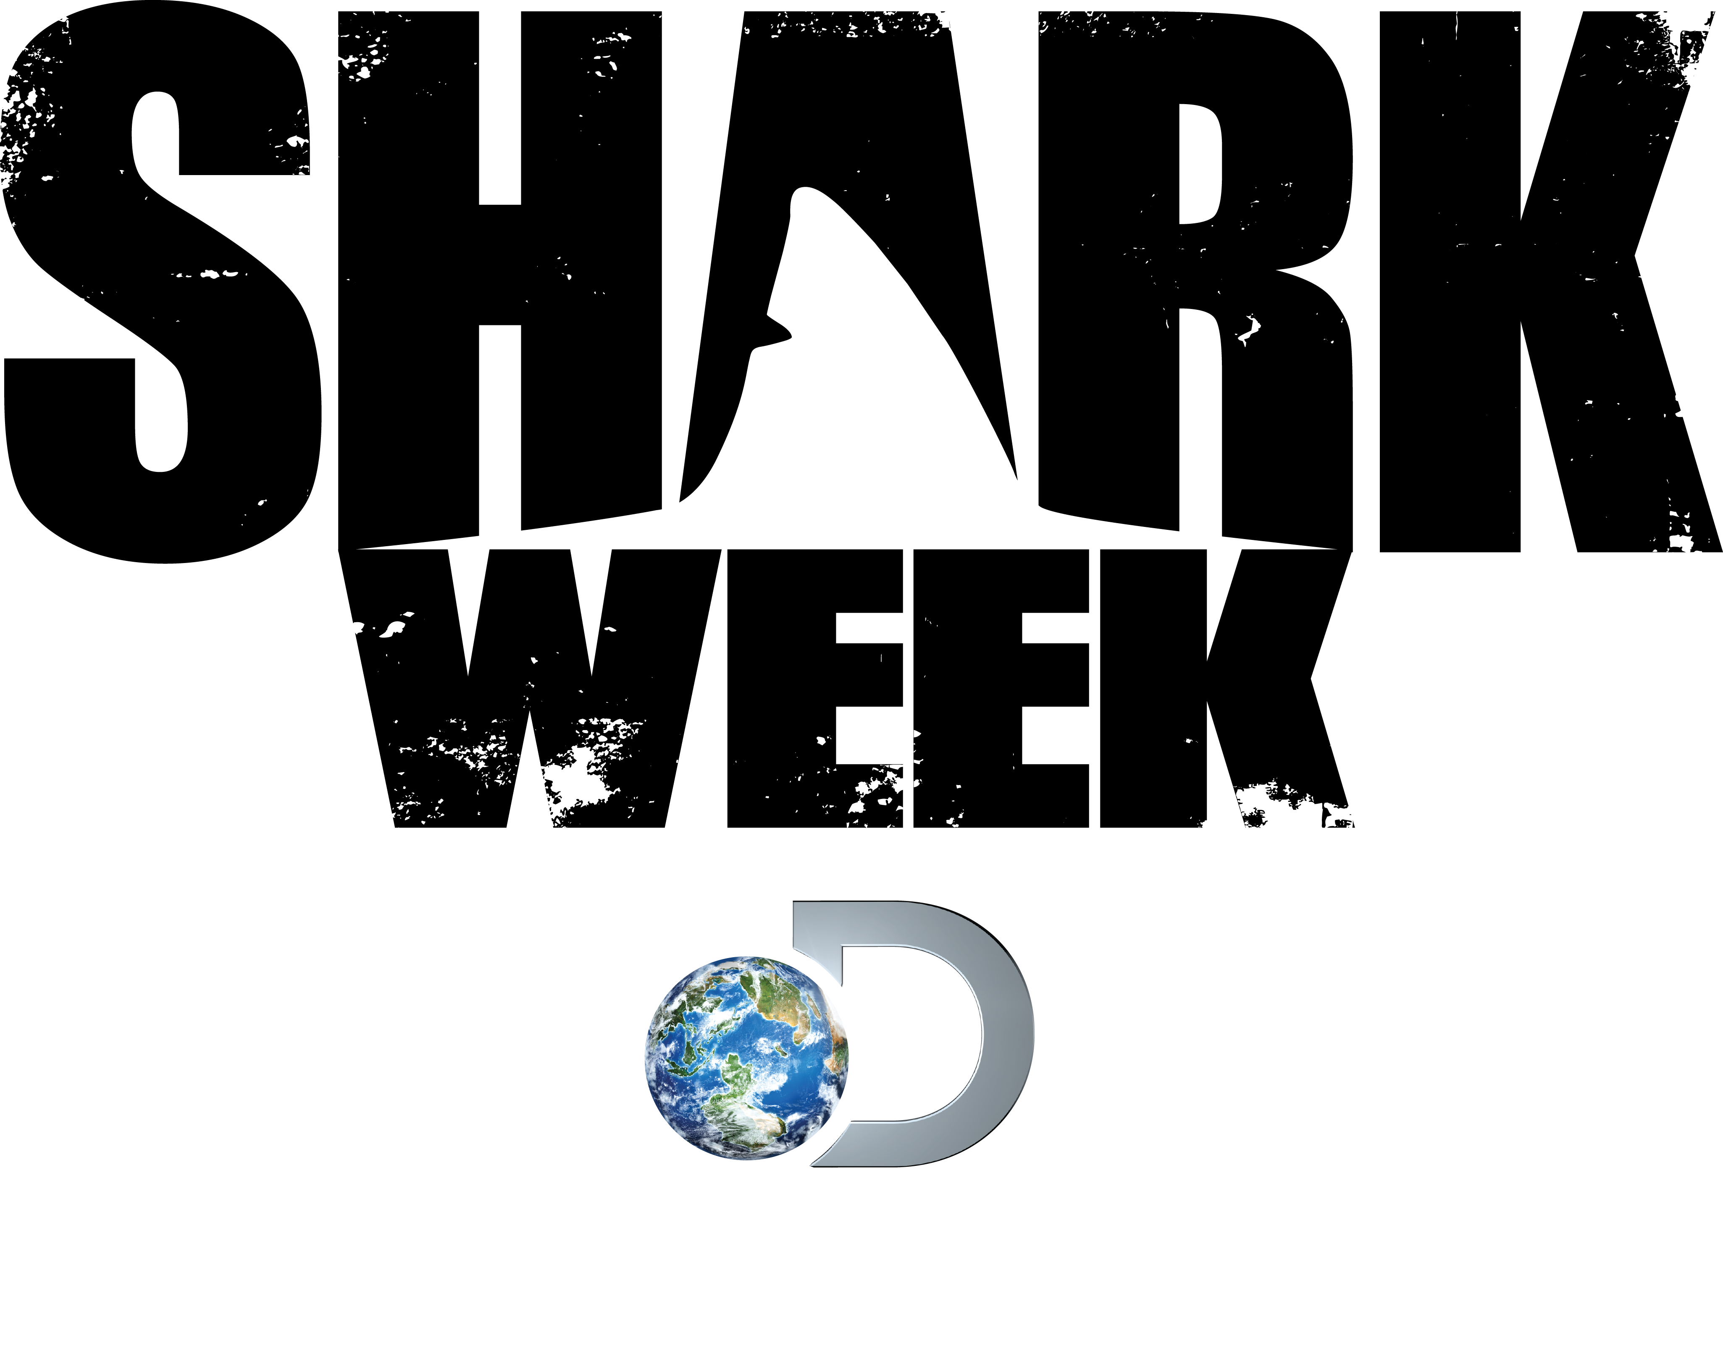
‘SHARK WEEK’ AT 27:
A HISTORY OF SUMMER’S MUST-SEE TELEVISION EVENT

SHARK WEEK: The “When”

Cable’s longest-running programming event, SHARK WEEK, first launched on Discovery Channel July 17, 1988.

SHARK WEEK: The “Why”

In the still-young world of cable television in the late 1980s, Discovery Channel was looking for fresh, innovative ways to draw viewer attention to the network’s offerings. The network knew that its viewers possessed an intense curiosity and fascination about the natural world, and particularly about predators like sharks. With a summer tie-in, Discovery programmers created the network’s very first weeklong event and dedicated it to sharks. It was called SHARK WEEK.

SHARK WEEK: Ratings Highlights

In its first year (1988), the prime-time rating for SHARK WEEK nearly doubled Discovery Channel’s normal prime-time average. Today it shows no sign of slowing in popularity and remains one of Discovery Channel’s – and cable’s – most popular annual events.

The Top 10 rated SHARK WEEK programs are:
*Denotes programs that are tied

- Megalodon: The Monster Shark Lives (2013)
- Ocean of Fear (2007)
- Anatomy of a Shark Bite (2003)
- Return of Jaws (2013)
- Voodoo Sharks (2013)
- Great White Serial Killer (2013)
- Ultimate Air Jaws (2010)
- *Great White Invasion (2011)
8. *Jaws Comes Home (2011)
- Air Jaws: Sharks of South Africa (2001)

Last year’s SHARK WEEK (2013) was watched by 53.17 million total viewers and ranks as the highest rated SHARK WEEK ever in all key demos. It was also Discovery Channel's most social programming event to date. There were 4.3 million @SharkWeek tweets, nearly 3.4 million discovery.com Shark Week video streams, and 21.8 million people were reached via Facebook.

SHARK WEEK: Program Highlights

Since 1988, SHARK WEEK has aired more than 161 shark programs (not including 2014). In 2014, Discovery Channel will air 12 new premieres and will also bring back last year’s late-night talk show Shark After Dark. A few highlights from 26 years of SHARK WEEK:

- SHARK WEEK launched on July 17, 1988 with the show Caged in Fear

- SHARK WEEK was first hosted in 1994 by “Jaws” author Peter Benchley

- In 1995, In Search of the Golden Hammerhead profiled an extremely rare shark that had never before been seen on television

- SHARK WEEK’s 10th Anniversary included Shark Bites: A Decade of Shark Week

- The first-ever live SHARK WEEK program aired in 1999. Live From a Shark Cage was hosted by journalist Forrest Sawyer and featured cinematographer Al Giddings

- The first-ever live late-night SHARK WEEK talk show aired in 2013. Shark After Dark was hosted by comedian Josh Wolf and included celebrity guests, shark experts and shark attack survivors. The show gave viewers the first opportunity to interact live on-air every night with tweets, questions to the shark experts and more.

- The 2000 SHARK WEEK included the first-ever 3-D shark program: Sharks 3-D

- Air Jaws – featuring great white breaching behavior never before caught on film – sent shockwaves through the scientific community upon its premiere in 2001

- Celebrities jumped into the water with sharks for SHARK WEEK’s 15th birthday in 2002 (see “The Hosts” section for list of celebrities)

- Two shows from 2011, Great White Invasion and Jaws Comes Home, made it to the Top 10 most-watched SHARK WEEK shows list, tied at #8

- Megalodon: The Monster Shark Lives, the most watched SHARK WEEK program from 2013, was also the most-watched program in SHARK WEEK history.

SHARK WEEK: The Hosts

SHARK WEEK was first hosted in 1994 by “Jaws” author Peter Benchley, when he introduced each program from “Jaws” movie locations. Subsequent SHARK WEEKs have been hosted by zoologist Nigel Marven (2000, 2001, 2002); Adam Savage and Jamie Hyneman from MythBusters (2005, 2008); Mike Rowe from Dirty Jobs (2006, 2008); Survivorman Les Stroud (2007); comedian and late night host Craig Ferguson (2010); and comedian Andy Samberg (2011).

SHARK WEEK has featured a variety of shark experts, journalists and celebrities through the years including Forrest Sawyer (Live From a Shark Cage, 1999); Heidi Klum (Sharks Under Glass, 2003); biologist Mike deGruy (numerous programs including 2006’s Perfect Shark); and animal behaviorist Dave Salmoni (Sharks: Are They Hunting Us?, 2006).

The 15th year (2002) was dubbed CELEBRITY SHARK WEEK. During that week, celebrities including actress Julie Bowen, singer/host Mark McGrath, singer Brian McKnight, and model/athlete Gabrielle Reece among others had thrilling shark adventures.

SHARK WEEK: Conservation Efforts

It is estimated that as many as 70 million sharks are killed annually, either for sport, caught as by-catch, or hunted for their fins in a wasteful practice called shark finning, in which the shark's fins are cut off at sea and the rest of the (live) shark is often tossed overboard where it ultimately drowns.

Discovery Channel has teamed with non-profit Oceana, the largest international organization focused solely on ocean conservation, since 2010. The network enlisted the expertise of Oceana to ensure the accuracy of shark programming and help spread the word about the plight of sharks including an “Adopt a Shark” media kit in 2010 in which a donation was made to Oceana for shark conservation on behalf of members of the press.

Discovery Channel also airs anti-finning Public Service Announcements (PSAs) during SHARK WEEK each year and features the network’s conservation partners and their efforts on the sharkweek.com fansite.

Press Contacts:
Kate Aconfora, 310-975-5902, Kate_Aconfora@discovery.com
Jackie Lamaj, 212-548-5607, Jackie_Lamaj@discovery.com

###

