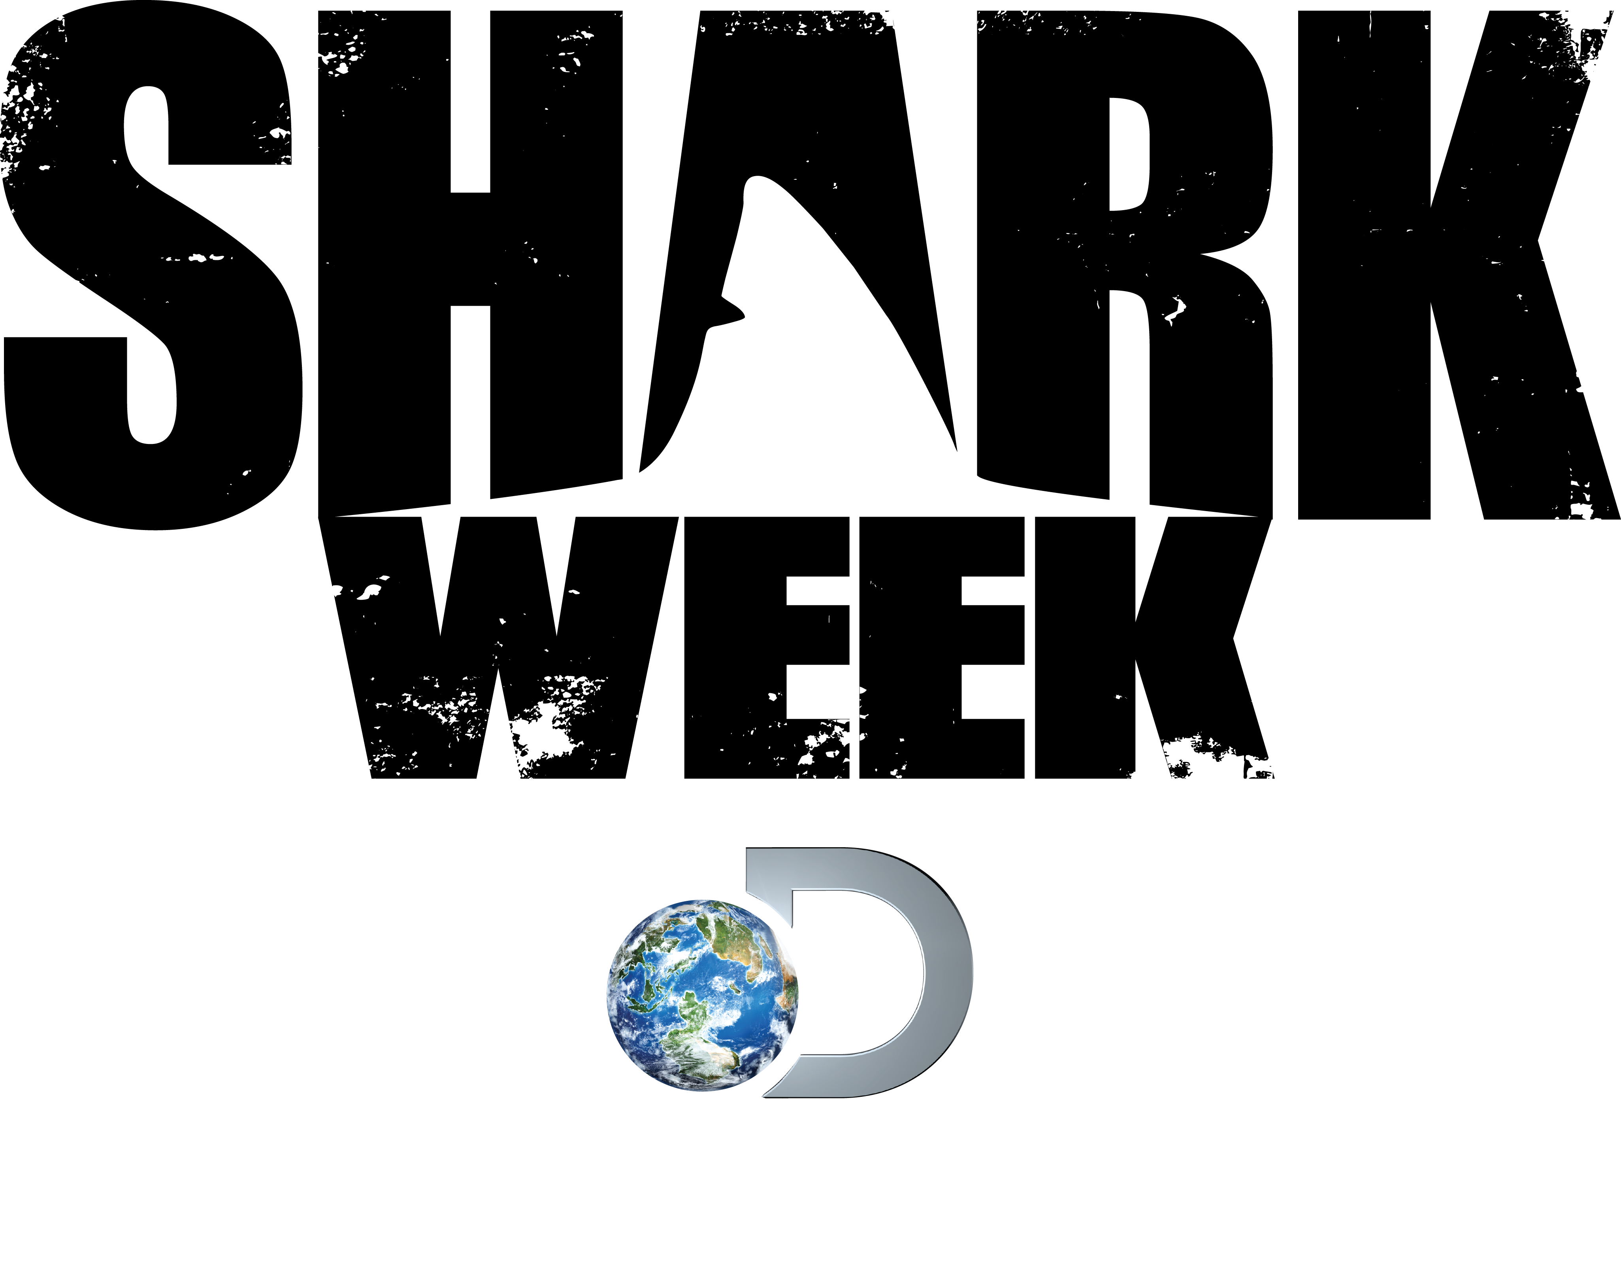
HIGHLIGHTS FROM 27 YEARS OF ‘SHARK WEEK’

1988: The first-ever SHARK WEEK show, Caged in Fear, aired on Discovery Channel July 17, 1988 at 9PM. The show description read: “A new motorized cage is tested for its resistance to shark attacks.” Nine additional shows premiered that year including Sharks – Predators or Prey, The Shark Takes a Siesta and Sharks of a Different Color. Ratings that week nearly doubled Discovery Channel’s primetime average.

1989: Due to phenomenal viewer response, Discovery Channel brought SHARK WEEK back for a second year. Programs included Shark: Maneater or Myth?, Shark Hunters of Achill Island and Sharks of San Francisco.

1990: Premieres included: Shark!: The World of Sharks and Barracuda and Sharks: Hunters of the Oceans.

1991: Billed as SHARK WEEK: The Revenge, premieres included Shark Shooters, Sea Lovers and Great Shark Hunt.

1992: SHARK WEEK: They’re Back swam onto the scene with four premieres: The Man Who Loves Sharks, featuring pioneer SCUBA diver and underwater producer Stan Waterman, Sharks of Polynesia, Great White Encounters and Great White! Parts 1 & 2.

1993: SHARK WEEK: We Dare You to Watch featured five premiere programs: African Shark Safari, Sharks on the Brink of Extinction, Teeth of Death, Assignment Adventure and Sharks of Pirate Island.

1994: For the first time ever, SHARK WEEK had a host. “Jaws” author Peter Benchley did the honors, just as his best-selling novel was celebrating its 20-year anniversary. Benchley introduced each program from the same locations where the “Jaws” motion picture was filmed.

1995: Premieres in 1995 included Sharks of the Red Triangle, Rendezvous at Ningaloo and In Search of the Golden Hammerhead, which profiled an extremely rare shark that had never before been seen on television.

1996: Premieres in 1996 included The Ultimate Guide: Sharks, Danger Beach and Tales of the Tiger Shark, which remains the third most watched SHARK WEEK program ever.

1997: Shark Bites: A Decade of Shark Week, a two-hour retrospective of some of the most thrilling moments of shark filmmaking on Discovery Channel, kicked off the 10th anniversary of SHARK WEEK.

1998: Prehistoric Sharks launched the 1998 SHARK WEEK, which looked at the most bizarre and unusual sharks to ever swim the earth’s waters. The week featured four additional premieres, including Zambezi Shark, Hammerheads: Nomads of the Sea and Great White: In Search of the Giants.

1999: SHARK WEEK went live in 1999 with a special two-hour program from the Pacific’s Bikini Atoll titled Live From a Shark Cage. Journalist Forrest Sawyer hosted the program, which featured renowned cinematographer Al Giddings.

2000: Dubbed SHARK WEEK UNCAGED, the weeklong event was hosted by zoologist Nigel Marven. Five all-new programs aired, including the first-ever 3-D shark program, Sharks 3-D.

2001: Host Nigel Marven returned with a lineup that featured one of the most talked-about shark programs ever to air on SHARK WEEK – Air Jaws: Sharks of South Africa. The special showcased first-ever footage of great white sharks literally launching themselves 15 feet above the water. It ranks as the fourth most watched SHARK WEEK show of all time.

2002: This year the sharks had co-stars. SHARK WEEK celebrated its 15th year with CELEBRITY SHARK WEEK. Hosted for the third year in a row by Nigel Marven, celebrities who took to the shark infested waters included Julie Bowen, Mark McGrath, David James Elliott, Adrian Pasdar, Estella Warren, Brian McKnight, Gabrielle Reece and Casper Van Dien.

2003: The second highest rated SHARK WEEK program of all time, Anatomy of A Shark Bite, premiered in 2003 and featured underwater and topside footage of an actual shark bite. Six additional premieres aired including a program hosted by Heidi Klum titled Sharks Under Glass.

2004: The week featured seven premiere programs, including Primal Scream, Tiger Shark Attack: Beyond Fear and Dive to Shark Volcano.

2005: MythBusters: Jaws Special, which saw the MythBusters testing famous myths about sharks, kicked off the week and currently ranks as the fifth most watched SHARK WEEK show of all time. Additional premiere programs included Sharkbite! Surviving Great Whites, American Shark and Shark Hunter, which told the story of the real-life captain who inspired the character Quint in the movie “Jaws.”

2006: SHARK WEEK 2006 kicked off with Dirty Jobs: Jobs That Bite, a two-hour special hosted by Mike Rowe that featured brave men and women who work with sharks. Other premieres included Shark Attack Survivors, Perfect Shark and Shark Rebellion.

2007: Discovery celebrated the 20th anniversary with eight all-new premieres and, for the first time ever, the network’s total day schedule (9AM to 3AM ET/PT) was devoted entirely to shark programs. “Viewers Choice” programs, voted on by fans, aired during the 8PM hour. Survivorman Les Stroud hosted the week and the kick-off show Ocean of Fear became the highest rated SHARK WEEK show ever.

2008: SHARK WEEK 2008 featured several fan favorites including SURVIVORMAN’s Les Stroud, MYTHBUSTERS’ Adam Savage and Jamie Hyneman and DIRTY JOBS’ Mike Rowe who each put their own spin on sharks – from surviving an attack to debunking popular myths to working at the edge of the Arctic Circle in search of the mysterious Greenland shark.

2009: The two-hour special Blood in the Water – the true story of a tragedy that took place in the summer of 1916 and later inspired the movie “Jaws” – kicked off SHARK WEEK 2009. And the elusive and deep-dwelling sixgill shark, found in the Puget Sound, made a rare appearance in Shark After Dark.

2010: Camera technology finally caught up with renowned producer Jeff Kurr’s vision and, nine years after Air Jaws: Sharks of South Africa, he returned with the jaw-dropping special Ultimate Air Jaws. For the first time, audiences saw a great white leaping out of the water 20-30 times slower than “typical” slow motion footage and in so much detail that you could literally count the shark’s teeth.

2011: Comedian Andy Samberg served as Discovery’s first-ever Chief Shark Officer (CSO) and voiced the special Shark City, featuring the sharks and other marine life that call Nassau home. Additionally, two premieres in 2011 tied for the eighth highest rated SHARK WEEK shows of all time: Great White Invasion and Jaws Comes Home.

2012: Discovery Channel celebrated the 25th anniversary of SHARK WEEK with eight all-new shows including the resurrection of the largest shark ever to swim in our oceans, a special highlighting the impact the blockbuster movie “Jaws” had on both sharks and the people who made it and a gripping special that reveals how two war heroes survived 47 days at sea in shark-infested waters. Also this year Discovery, via the HD App for iPad, offered an engaging digital companion to the weeklong line-up to include audio-synched behind-the-scenes factoids, photos, quizzes and social conversation.

2013: Building upon last year’s eight specials, a whopping 11 shark-filled episodes coupled with the first ever late night SHARK WEEK talk show gave this year’s SHARK WEEK the most premiere hours ever featured in the 26-year history of the event. Viewers were introduced to “Shark Cam,” the first robot submarine that was used to track sharks in a new and exciting way. 2013’s SHARK WEEK was watched by 53.17 million total viewers and ranks as the highest rated SHARK WEEK ever in all key demos. It was also Discovery Channel's most social programming event to date.

2014: In 2014, Discovery Channel will air 12 new premieres and will also bring back last year’s late-night talk show Shark After Dark.

###

Press Contacts:
Kate Aconfora, 310-975-5902, Kate_Aconfora@discovery.com
Jackie Lamaj, 212-548-5607, Jackie_Lamaj@discovery.com

