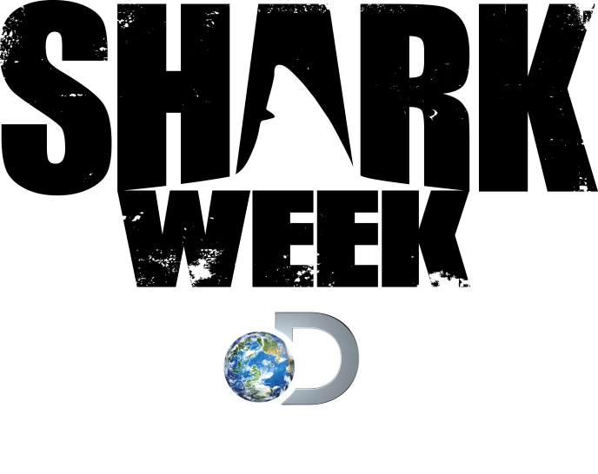
SHARK WEEK 2014 PROGRAMMING

I ESCAPED JAWS 2 – Airing Thursday, August 14th at 9PM ET/PT
Shark attacks victims recount their harrowing near death experiences and reveal how they escaped with their lives.

ALIEN SHARKS: RETURN TO THE ABYSS Airing Tuesday, August 12th at 9PM ET/PT
Shark researchers investigate the ocean’s darkest depths in search of shark species that have never been seen before on camera and get a glimpse of the elusive ghost shark.
GREAT WHITE MATRIX Airing Saturday, August 16th at 9PM ET/PT
Shark attack survivor Paul de Gelder and Andy Casagrande head deep into the shark infested waters of Australia to investigate a series of bizarre shark attacks and capture the great white bite on camera.
AIR JAWS: FIN OF FURY Airing Sunday, August 10th at 8PM ET/PT
Using incredible new cameras and high tech underwater gadgetry, Shark Filmmaker Jeff Kurr and his team embark on a worldwide mission to track down the missing “mega-shark” Colossus.

JAWS STRIKES BACK Airing Monday, August 11th at 9PM ET/PT
Marine biologist Greg Skomal and the sharkcam team travel to the remote Pacific island of Guadalupe to film the hunting behavior of the largest great white sharks on earth.

ZOMBIE SHARKS Airing Wednesday, August 13th at 9PM ET/PT
Shark Diver and conservationist Eli Martinez explores a catatonic zombie-like state in sharks called “tonic immobility” and sets out to solve a mystery of predators using it on massive great whites.
SPAWN OF JAWS: THE BIRTH Airing Wednesday, August 13th at 10PM ET/PT
Dr. Michael Domeier continues his quest to unlock one of the greatest shark mysteries: the location of great white pupping grounds. This two year mission follows the journey of a pregnant great white called Gil Rakers as she prepares to give birth.

MONSTER HAMMERHEAD Airing Monday, August 11th at 10PM ET/PT
For the past 60 years reports of a monster hammerhead clocking in at over 20 feet long have circulated throughout Florida. Now, a team of scientists and anglers explore the waters of the world’s largest hammerheads to see if these stories could be true.

SHARK OF DARKNESS: WRATH OF SUBAMRINE Airing Sunday August 10th at 9PM ET/PT
Said to be the deadliest great white shark of all time, “Submarine” is a 30 foot great white that has terrorized the shores of South Africa for decades. Locals believe that this shark is responsible for countless fatal attacks, but its existence has never been proven.

SHARKAGEDDON Airing Thursday, August 14th at 10 PM ET/PT
Massive tiger sharks and other predatory species are invading the shores of Hawaii. After a spike in attacks including two fatalities, Hawaiian native and surf legend Kala Alexander sets out to uncover the truth behind what’s disrupting the Hawaiian food chain.

MEGALODON: THE NEW EVIDENCE Airing Friday, August 15th at 10PM ET/PT
Collin Drake returns to share new details of his case and present the shocking new evidence of the existence of Megalodon, an enormous prehistoric shark that could still be roaming the oceans.
LAIR OF THE MEGA SHARK Airing Tuesday, August 12th at 10PM ET/PT
Shark Experts Jeff Kurr and Andy Casagrande head to New Zealand to investigate the sightings of a 20-foot great white shark which leads them to the nocturnal feeding ground of a “mega-shark”.
SHARKSANITY Airing Saturday, August 16th at 10PM ET/PT
A look at the most insane bites, strikes and close calls from Shark Week 2014. Plus, your picks for the 5 craziest Shark Week moments ever.

SHARK AFTER DARK
SHARK WEEK’s late-night live talk show, Shark After Dark, will return. Host Josh Wolf will lead viewers through an hour-long celebration of all things shark-related, including celebrity guests and shark experts. The talk show will give viewers the opportunity to interact live on-air every night with tweets, questions to celebrity guests, and more.

All Times Eastern/Pacific

Press Contacts:
Kate Aconfora, 310-975-5902, Kate_Aconfora@discovery.com
Jackie Lamaj, 212-548-5607, Jackie_Lamaj@discovery.com

