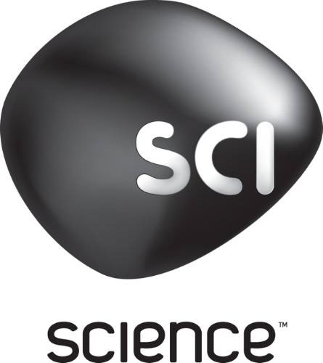

SCIENCE CHANNEL EXPLORES RELIGION’S GREATEST MYSTERIES
IN THE WORLD PREMIERE OF BIBLICAL CONSPIRACIES

-- Epic Two-Night Event Premieres on Sunday, December 14 & Monday, December 15 --

(Silver Spring, MD)- Science Channel, the network that dares to question everything, explores the science behind the faith in a four-part special event BIBLICAL CONSPIRACIES. The greatest archeological finds and some of the most beloved icons of the Judeo-Christian religions are examined and age-old secrets explored. Could two twisted nails found in the tomb of the man who sent Jesus to the cross be the very same from the True Cross? Does a recently translated 6th century manuscript tell the true story of Jesus’ marriage to Mary Magdalene? And could a forgotten sculpture made by Michelangelo bring to light strange and long-buried religious practices from the time of Christ? With the aid of cutting edge technology, we return to the crumbling tombs, palaces and ruins of the Holy Land, in search of ancient conspiracies hidden away for two thousand years and Science Channel will take us through all the ground-breaking mysteries behind the myths. Biblical Conspiracies premieres with a four-part special on Science Channel on Sunday, December 14 beginning at 9PM ET/PT and Monday, December 15 at 8PM ET/PT.

BIBLICAL CONSPIRACIES TRAILER
https://www.youtube.com/watch?v=AxUOn_Q1yus&list=UUvJiYiBUbw4tmpRSZT2r1Hw

Angel or Cupid? CLIP
Link: https://vimeo.com/113294781
Password: bible
Downloadable clip: https://www.hightail.com/download/UlRRYlJURndkMnVFQk1UQw

EPISODE ONE: NAILS OF THE CROSS
Premieres on Sunday, December 14 at 9PM ET/PT
In 1981, the tomb of the High Priest Caiaphas – who according to the Gospels sent Jesus to the cross – was unearthed in Jerusalem. Along with other artifacts, two Roman nails were recorded in the official excavation report. The film tracks a 5-year investigation into these nails. Using electron microscopes and other state-of-the-art tools, scientists have made a remarkable discovery that proves beyond a doubt that the nails in question were used in a crucifixion. Could these be the nails used to crucify Jesus?

EPISODE TWO: SECRETS OF THE SCULPTURE
Premieres on Monday, December 15 at 8PM ET/PT
Michelangelo’s magnificent sculpture – the Pietà – is the most iconic image ever made of the Virgin Mary holding her crucified son. It may very well be the most famous sculpture ever. And yet, from the moment it was unveiled, it has held an enduring mystery. Why does the mother seem younger than the son? It may seem like an unanswerable question, but a new discovery hints at a millennia old secret. A terra cotta sculpture just attributed to Michelangelo contains a secret symbol that unlocks an untold story of murder, sex and politics with Michelangelo at its center.

EPISODE THREE : SECRETS OF THE CRUCIFIXION
Premieres on Monday, December 15 at 9PM ET/PT
This episode tracks several interrelated stories. These include the archaeological discovery in Jerusalem of the physical remains of “Mattathiah (Matthew) son of Judah”, also known as Antigonus, the last legitimate king of Israel, and the scientific investigation of a crucified hand – an unprecedented find – unearthed in Antigonus’ tomb. Can the scientific exploration of this find teach us how Jesus was crucified?

EPISODE FOUR: BRIDE OF GOD/THE LOST GOSPEL
Premieres on Monday, December 15 at 10PM ET/PT
Gathering dust in the British Library is an ancient manuscript of the early Church, written by an anonymous monk. The manuscript is at least 1,500 years old, possibly dating even further – back to the 1st century and the religious activism of Jesus of Nazareth. After millennia of rumors, this seems to be the first solid written evidence that Jesus was married to Mary Magdalene. The manuscript also recounts that the Magdalene was a gentile, that Jesus and Mary had children and that for their earliest followers they were Mr. and Mrs. Messiah.

*Pegasus Books has released critically-acclaimed THE LOST GOSPEL, a historical detective story that unravels a newly translated document filled with startling revelations and fascinating detail about the life and times of Jesus of Nazareth. This book takes the reader on an unparalleled historical adventure through a paradigm shifting manuscript. What the authors eventually discover is as astounding as it is surprising. Part historical detective story, part modern adventure this book reveals secrets that have been hiding in plain sight for millennia. http://pegasusbooks.com/books/the-lost-gospel-hardcover
About Science Channel
Science Channel, a division of Discovery Communications, Inc, is home for the thought provocateur, the individual who is unafraid to ask the killer questions of "how" and "why not." The network is a playground for those with audacious intellects and features programming willing to go beyond imagination to explore the unknown. Guided by curiosity, Science Channel looks for innovation in mysterious new worlds as well as in its own backyard. Science Channel and the Science Channel HD simulcast reach nearly 80 million U.S. households. The network also features high-traffic online and social media destinations, including ScienceChannel.com, facebook.com/Science Channel and twitter.com/ScienceChannel.

About Discovery Communications, Inc.
Discovery Communications (Nasdaq: DISCA, DISCB, DISCK) is the world's #1 pay-TV programmer reaching nearly 3 billion cumulative subscribers in more than 220 countries and territories. Discovery is dedicated to satisfying curiosity, engaging and entertaining viewers with high-quality content on worldwide television networks, led by Discovery Channel, TLC, Animal Planet, Investigation Discovery and Science, as well as U.S. joint venture network OWN: Oprah Winfrey Network. Discovery also controls Eurosport International, a premier sports entertainment group, including six pay-TV network brands across Europe and Asia. Discovery also is a leading provider of educational products and services to schools, including an award-winning series of K-12 digital textbooks, through Discovery Education, and a digital leader with a diversified online portfolio, including Discovery Digital Networks. For more information, please visit www.discoverycommunications.com.

###

