**FOR IMMEDIATE RELEASE**:                                         
August 25, 2015

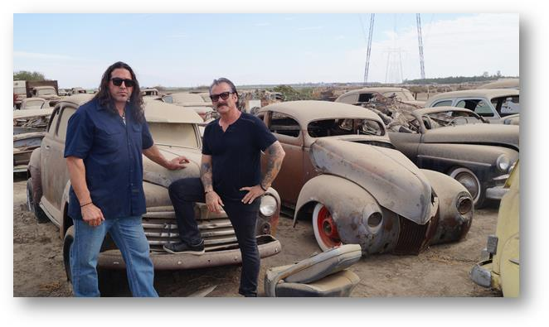 ***RUSTED DEVELOPMENT RETURNS FOR A SECOND SEASON TO DISCOVERY CHANNEL ON MONDAY, SEPTEMBER 7 AT 10PM ET/PT***

*-Rick Dore and Chuck Palumbo are back with a new garage and more unexplored hoards-*

(Silver Spring, MD) – Hidden just out of sight in backyards and garages across the country are vast treasure troves of an Americana relic-- classic cars. Custom car guru, Rick Dore and WWE superstar Chuck Palumbo are back to rebuild legendary cars and transform lives in the return of **RUSTED DEVELOPMENT** (*fka* *Lords of the Car Hoards*) to premiere on Discovery Channel Monday, September 7 at 10 PM/ET.

After being forced to shut the doors to SLAM garage in the previous season, our two car experts are reopening SLAM, and jumping back into the “hoarder scene" with challenges more daunting than ever. This season has everything from six-figure builds including a 1937 Zephyr (the “holy grail” of custom cars), to a Vietnam war veteran who hopes to honor his late father’s memory by rebuilding a 1957 Thunderbird. Palumbo also takes on a project very close to his heart- restoring his father’s 1965 Corvette, a car that set him on his career path.

Each episode of **RUSTED DEVELOPMENT** features Dore and Palumbo helping car hoarders by offering them the deal of a lifetime: pick any one dream car from their overcrowded collection to get a custom rebuild. The catch: they have to cover the costs of the remake by parting with and selling other cars and parts from their massive hoard. Many of these car hoards have been collected over a lifetime and even with the promise of a priceless new custom car, the separation anxiety sets in as car owners can’t let go.

Dore, a classic car legend known for his vivid imagination, has been in the custom car building game for decades. A member of numerous automotive halls of fame, the recipient of three top awards at the 2014 Grand National Roadster Show (where he debuted The Aquarius, which he built for James Hetfield of Metallica), his one-of-a-kind creations regularly grace the covers of hot rod magazines. Palumbo, the 6'6" athlete and wrestling superstar holds many world wrestling titles, including two WWE Tag team titles and four WCW World Tag Team titles. He left WWE in 2008 to pursue his passion for cars and motorcycles.

**RUSTED DEVELOPMENT** is produced for Discovery Channel by Discovery Studios where Emi Macuaga served as Executive Producer and Graham Hughes served as the Co- Executive Producer. For DNI, Commissioning Editor is Elizabeth McIntyre and Executive Producer is Victoria Noble. For Discovery Channel, executive producer is Craig Coffman with Todd Lefkowitz as coordinating producer and Greg Wolf as associate producer.

**About Discovery Channel**

Discovery Channel is dedicated to creating the highest quality non-fiction content that informs and entertains its consumers about the world in all its wonder, diversity and amazement. The network, which is distributed to 100.8 million U.S. homes, can be seen in 224 countries and territories, offering a signature mix of compelling, high-end production values and vivid cinematography across genres including, science and technology, exploration, adventure, history and in-depth, behind-the-scenes glimpses at the people, places and organizations that shape and share our world. For more information, please visit [www.discovery.com](http://www.discovery.com)

**About Discovery Communications**

Discovery Communications (Nasdaq: DISCA, DISCB, DISCK) is the world’s #1 pay-TV programmer reaching nearly 3 billion cumulative subscribers in more than 220 countries and territories. For 30 years Discovery has been dedicated to satisfying curiosity and entertaining viewers with high-quality content through its global television brands, led by Discovery Channel, TLC, Animal Planet, Investigation Discovery and Science, as well as U.S. joint venture network OWN: Oprah Winfrey Network. Discovery controls Eurosport, the leading pan-regional sports entertainment destination across Europe, Asia Pacific, the Middle East and Africa. Discovery also is a leading provider of educational products and services to schools, including an award-winning series of K-12 digital textbooks, through Discovery Education, and a digital leader with a diversified online portfolio, including Discovery Digital Networks. For more information, please visit [www.discoverycommunications.com](http://www.discoverycommunications.com).

###