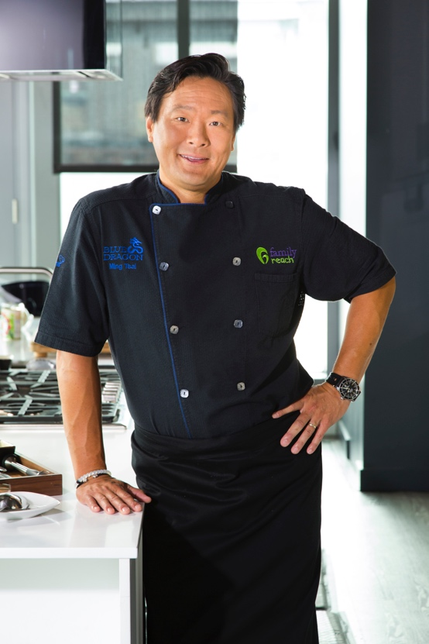

Ming Tsai Bio

Ming Tsai is the James Beard Award-winning chef/owner of Blue Ginger and Blue Dragon. Both are located in Massachusetts and feature Ming's signature East-West cuisine.

An Emmy Award-winner, Ming is also the host and executive producer of PBS-TV's Simply Ming, now in its fourteenth season. Simply Ming brings a variety of both studio and location cooking to drive inspiration and demonstrate today's techniques. Ming is the author of five cookbooks including the interactive Simply Ming In Your Kitchen.

Ming is a national spokesperson for the Food Allergy Research and Education (FARE) organization. Ming also worked with Massachusetts Legislature to help write Bill S. 2701 that requires local restaurants to comply with food allergy awareness guidelines.

In 2012, Ming was invited by Secretary of State Hillary Clinton to represent the U.S. with the Diplomatic Culinary Partnership Initiative/American Chef Corps. The Chef Corps is a network of American chefs that participate with official government programs that use food as a foundation for international diplomacy efforts.

A member of the Harvard School of Public Health's Nutrition Round Table, Ming also supports many charities including Family Reach of which he is the President of the National Advisory Board, Big Brothers Big Sisters, Cam Neely Foundation, Common Threads and Greater Boston Food Bank. For more information, visit www.ming.com.

