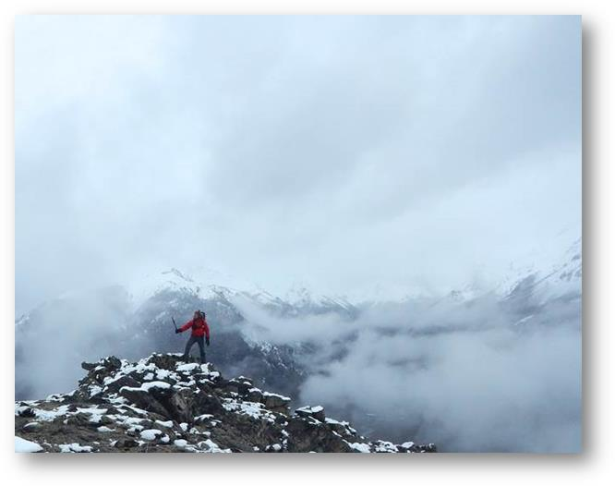

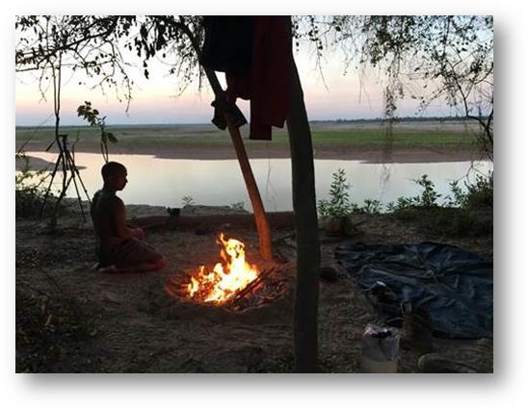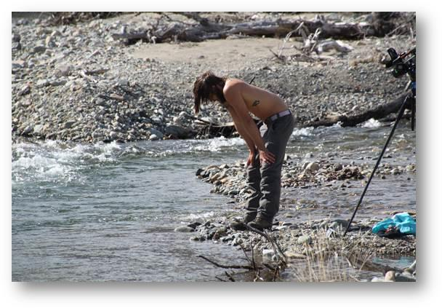



**FOR IMMEDIATE RELEASE**:                                               
December 7, 2016

**DISCOVERY CHALLENGES SURVIVALISTS TO CONQUER SIX DEADLY TERRAINS IN NEW ADVENTURE SERIES ‘THE WHEEL’**

*THE WHEEL starts turning Friday, January 13, at 10PM ET/PT*

(Los Angeles) – Discovery is putting a new spin on the survivalist genre with **THE WHEEL**, the network’s new adventure series from Pilgrim Media Group. **THE WHEEL**dares six participants to survive in six distinctly grueling landscapes across South America. With every turn of the wheel, each survivalist is dropped into a new isolated location, exposed to the world’s deadliest terrains including freezing tundra, rugged mountains and treacherous rainforest. Participants don’t know when or why the wheel will turn – nor that their stint at each spot is determined by the rotation of the moon. Equipped only with light survival packs and SOS devices that can be used at any time to quit the challenge and call for help, they must fend for their lives by procuring food, water and shelter. And when the wheel turns again, they will be thrust into a new location, forced to use a completely different set of skills to survive.  **THE WHEEL premieres Friday, January 13, at 10 PM ET/PT on the Discovery Channel**.

**THE WHEEL** is the ultimate survival challenge: survive not one, but six lethal environments over the course of 60 days. The participants are not typical survival experts, but rather everyday people with something to prove. Unbeknownst to them, the wheel is a mechanism that mirrors the lunar calendar. With every phase of the moon, the wheel will turn and send each person to a new eco-zone. The amount of time at each location is revealed only to viewers, leaving the survivors to agonize and obsess over when the wheel will spin again. As every rotation thrusts them – without warning – into a new harrowing domain, participants are completely at the wheel’s mercy.

Will the survivalists have what it takes to endure the harsh terrains? Or will the challenges prove insurmountable? Watch as participants battle the elements and their own mental stamina to see who will survive **THE WHEEL**.

**THE WHEEL** is produced for Discovery Channel by Pilgrim Media Group. For Pilgrim Media Group, executive producers are Craig Piligian and Sam Korkis. For Discovery Channel, executive producer is Joseph Boyle and coordinating producer is Brian Peterson. To learn more, go to [www.discovery.com](http://www.discovery.com), on Facebook at Facebook.com/discovery and on Twitter @Discovery.

**About Discovery Channel**

Discovery Channel is dedicated to creating the highest quality non-fiction content that informs and entertains its consumers about the world in all its wonder, diversity and amazement. The network, which is distributed to 100.8 million U.S. homes, can be seen in 224 countries and territories, offering a signature mix of compelling, high-end production values and vivid cinematography across genres including, science and technology, exploration, adventure, history and in-depth, behind-the-scenes glimpses at the people, places and organizations that shape and share our world. For more information, please visit [www.discovery.com](https://na01.safelinks.protection.outlook.com/?url=http%3A%2F%2Fwww.discovery.com%2F&data=01%7C01%7CSamara_Sims%40discovery.com%7C40afdffc3aa94474d0a208d41b1c73bc%7C092a1ba4a4fe4172970e7ab3035e7c94%7C0&sdata=aSkb7je0ZiVY2UARsrbjogQuJMrZg8pcThjmSDdcjwQ%3D&reserved=0)

**About Discovery Communications**

Discovery Communications (Nasdaq: DISCA, DISCB, DISCK) satisfies curiosity and engages superfans with a portfolio of premium nonfiction, sports and kids programming brands. Reaching 3 billion cumulative viewers across pay-TV and free-to-air platforms in more than 220 countries and territories, Discovery’s portfolio includes the global brands Discovery Channel, TLC, Investigation Discovery, Animal Planet, Science and Turbo/Velocity, as well as OWN: Oprah Winfrey Network in the U.S., Discovery Kids in Latin America, and Eurosport, the leading provider of locally relevant, premium sports content across Europe. Discovery reaches audiences across screens through digital-first programming from Discovery VR, Seeker and SourceFed Studios, as well as over-the-top and TV Everywhere offerings including Eurosport Player, Dplay, Discovery K!ds Play and Discovery GO. For more information, please visit [www.discoverycommunications.com](https://na01.safelinks.protection.outlook.com/?url=http%3A%2F%2Fwww.discoverycommunications.com%2F&data=01%7C01%7CSamara_Sims%40discovery.com%7C40afdffc3aa94474d0a208d41b1c73bc%7C092a1ba4a4fe4172970e7ab3035e7c94%7C0&sdata=Dp4G4z4nDlNSKKfNL5mQM2k0p2Mbf3QZPQJIPqYcutU%3D&reserved=0).

**CONTACT:**

Laurie Goldberg, 310-975-1631

[Laurie_Goldberg@Discovery.com](mailto:Laurie_Goldberg@Discovery.com)

Samara Sims, 310-975-5902  
[Samara_Sims@Discovery.com](mailto:Samara_Sims@Discovery.com)

Jackie Lamaj, 212-548-5607

[Jackie_Lamaj@Discovery.com](mailto:Jackie_Lamaj@Discovery.com)

The locations include:

**Amazon Rainforest** - The species that inhabit this place are equal parts flamboyant and lethal. From the steely-eyed jaguar to the green anaconda that slithers around the Amazon waiting to swallow its prey in one bite. The Amazon is a fiercely dangerous environment. Poison dart frogs, flesh-hungry crocodiles, curare plants that paralyze the respiratory system…these are just a few of the challenges the participants will face.

**Wetlands** - Pantanal, the world’s largest tropical wetland area is the mecca of wildlife beauty and danger. This gigantic season floodplain is home to a staggering variety of deadly plants and wildlife. During the rainy season, most of this plain is submerged and come dry season, it reappears bringing all sorts of flesh-starving creatures to the surface.

**Bush Plains** - Known as ‘the Impenetrable’ or the African savannah of South America, this sparsely populated, hot, and semi- air plain in Northern Argentina has some of the highest temperatures in the content that reach up to 120 degrees. Land of jaguars, lagoons, dust and eagles, it is both feared and esteemed by hunters. Punishing and disorienting, it’s a real life-threatening environment.

**Mountains** -The imposing Andes Mountains of Patagonia are teeming with glaciers, gushing rivers and snowed mountains. Temperatures averaging below freezing will make this a truly challenging location to survive.

**Tundra** - The unrelenting gusty wind and baron landscape of the Patagonian steppe make an incredibly difficult place to source food and shelter. It takes a real mental and physical commitment to survive the frozen tundra.

**Island** - Chiloe Island was Charles Darwin’s fascination. Located in the Pacific in Southern Chile, it is frequently shrouded in mist. This painfully desolate environment will drive survivalists to the brink of madness.