FOR IMMEDIATE RELEASE
November 9, 2020

OWN ANNOUNCES DOCUMENTARY FILM ACQUISITION OF ‘(IN)VISIBLE PORTRAITS’
FROM THOUGHT LEADER, STORYTELLER AND FILMMAKER OGE EGBUONU
AS AN OWN SPOTLIGHT SPECIAL PRESENTATION IN 2021

Documentary is a Powerful Celebration of Black Women
Sharing Their Stories of Struggle and Resilience

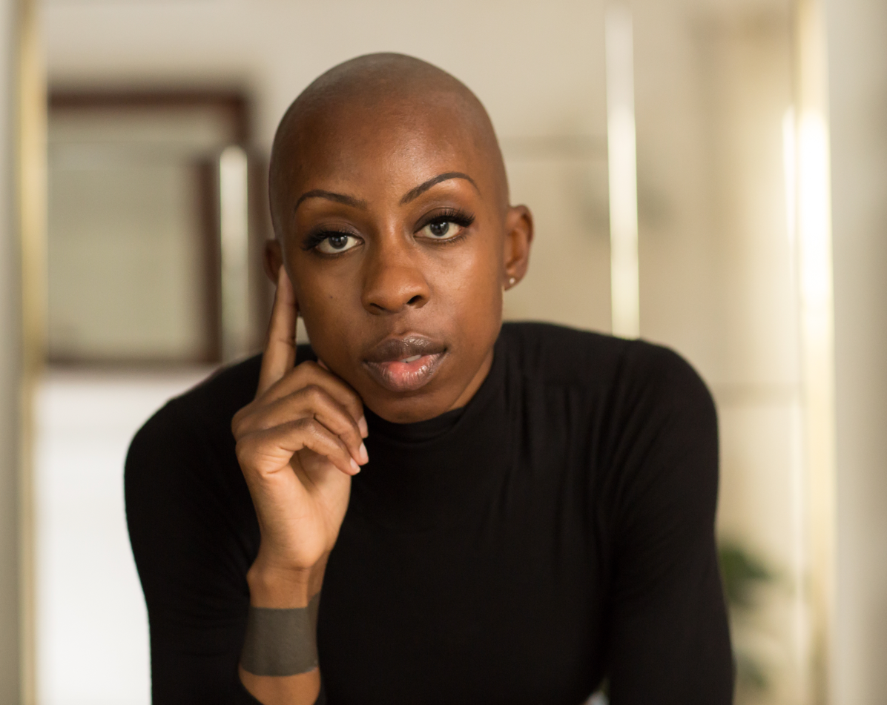
Click link below for hi-res image:
https://owncomm.box.com/s/rnwk5lx9gncygifaq5gctz8qcc235ygn

LOS ANGELES – OWN: Oprah Winfrey Network announced today the acquisition of the evocative documentary film “OWN Spotlight: (In)Visible Portraits” from thought leader, storyteller and filmmaker, Oge Egbuonu, as her directorial debut to air in 2021. Nearly three years in the making, (In)Visible Portraits is a powerful celebration of Black women sharing their stories of struggle, resilience and beyond. IndieWire described the film as “simply another facet of a story that demands to be watched” and Variety said “the documentary’s emotional generosity and mindful elegance impress.”

“Oge’s artistry and visionary storytelling in this beautiful film will deeply resonate with our viewers,” said Tina Perry, OWN president. “I am so proud showcase its important message which so perfectly aligns with OWN’s commitment for Black women to see themselves and their lives reflected and celebrated in our programming.”

“Creating this documentary was a personal feat,” says Oge Egbuonu, “as a Black woman, I have been told all my life the things that I cannot do and why it has been impossible for people who look like me to live full, unapologetic and authentic lives. Joining forces with OWN, who is so passionate about amplifying the message of this film, is a deeply gratifying opportunity. This film unapologetically affirms Black women and offers a poetic invitation that says I see you, I hear you and you matter. This documentary speaks to the times and my unshakable belief that healing begins when voices are heard, so I could not be more grateful for the enthusiastic support from OWN and their passion to share this with their audience.”

As described by Egbuonu as a “love letter to Black women and a reeducation for everyone else,” the documentary shatters the too-often invisible otherizing of Black women in America and reclaims the true narrative as told in their own words. The film illuminates the history of how we got here, dismantles the false framework of the present-day reality and celebrates the extraordinary heritage of exceptional Black women whom have come before as well as igniting hope for the next generations.

The special is executive produced by Oge Egbuonu and Michael Meyer.

About Oge Egbuonu
Oge Egbuonu is a thought leader focused on disruptive and inspirational storytelling. Her documentary “(In)Visible Portraits” was digitally released via Vimeo On Demand on Juneteenth (June 19, 2020), the American holiday celebrating June 19, 1865 when the Emancipation Proclamation was finally read to enslaved African-Americans in Texas.

Prior to creating “(In)Visible Portraits,” Oge produced films like “Loving” (the critically acclaimed film starring Joel Edgerton and Ruth Negga about Loving v. Virginia, the Supreme Court case which legalized interracial marriage in the United States) and “Eye in the Sky” at the independent production company Raindog Films alongside co-founders Ged Doherty and Academy Award®-winning actor Colin Firth. Oge also previously held a seat on the board of the Diversity Committee for the BRIT Awards, where she collaborated on revamping the voting academy and tackling diversity within the music and film industries.

About OWN Spotlight Programming
“OWN Spotlight” presentations tackle issues and concerns facing Black lives. The programs feature candid and in-depth conversations that create real dialogue to inspire systematic change. Previous programs include the two-night special “Where Do We Go From Here?” that simulcast across the Discovery family of networks featuring Oprah and Black thought leaders discussing the current state of racism America; “Oprah and 100 Black Fathers” sharing the urgency of having “the talk” with their children and the dreams they have for the future of their families; “COVID-19: The Deadly Impact on Black America” that investigated the disproportionate impact of the coronavirus pandemic on Black communities; “Oprah At Home with Lupita Nyong’o and Cynthia Erivo,” which examined colorism in Hollywood; “Oprah and Alicia Keys – The Interview” discussing Alicia Keys’ new memoir “More Myself;” “When They See Us Now” featuring Oprah in conversation with award-winning filmmaker Ava DuVernay and the cast from the acclaimed series “When They See Us” along with real men formerly known as the Central Park Five; and the follow-up documentary from D. Channsin Berry “Dark Girls 2” exploring the prejudices darker-skinned women face around the world.

About OWN: Oprah Winfrey Network
OWN: Oprah Winfrey Network is the first and only network named for, and inspired by, a single iconic leader. Oprah Winfrey’s heart and creative instincts inform the brand and the magnetism of the channel. OWN is a leading destination for a premium scripted and unscripted programming from today’s most innovative storytellers. OWN connects with its audience wherever they are, inspiring conversation among a global community of like-minded viewers on social media and beyond. Launched on January 1, 2011, OWN is a joint venture between Harpo, Inc. and Discovery, Inc. The venture also includes award-winning digital platform Oprah.com. Access OWN anytime on http://WatchOWN.tv or across mobile devices and connected TVs.

###

Media Contact:
James Ward III
OWN: Oprah Winfrey Network
323-602-1773
James_Ward_III@own.tv

