FOR IMMEDIATE RELEASE Contact: Amy Hagovsky, 240-662-2931
November 7, 2011 Amy_Hagovsky@discovery.com

RELIVE THE EPIC ADVENTURE AS EXPLORER ED STAFFORD BECOMES FIRST TO TAKE ON WORLD’S LONGEST RIVER IN DISCOVERY’S ‘WALKING THE AMAZON’

-- Two-Hour Special to Make U.S. Debut on Saturday, November 19th at 8PM E/P --

(Silver Spring, Md.) – Ex-soldier and explorer Ed Stafford and his friend Luke Collyer took on a monumental challenge: trace on foot the entire length of the Amazon, from its source in Southern Peru to its mouth on the Brazilian coast. And they would film the entire journey themselves – without a camera crew. They believed it would take them one year and would involve walking 4,000 miles. In the end, two and a half years and 6,000 miles later, only Stafford would make it to journey’s end. Viewers can join Ed for his journey on a two-hour special titled WALKING THE AMAZON, premiering on Discovery Channel Saturday, November 19th at 8PM E/P.

Along the way, Stafford climbed an 18,000-foot mountain, filmed never-before-seen tribal ceremonies and was mistaken for a man buying human organs. He also met a remarkable local guide named Cho who, after Luke’s departure, accompanied Ed on his mammoth trek. As well as filming all his own footage and demonstrating the skills needed for survival (often on little or no food), this is a vivid portrait of a man driven to the edge of his own sanity to join the ranks of the greatest explorers of all time.

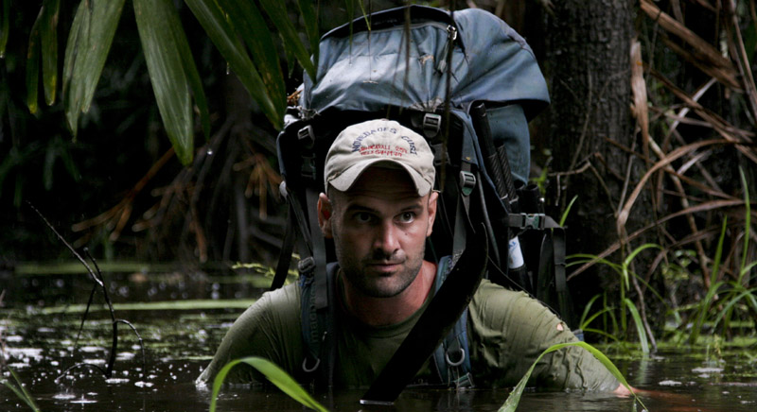

The Facts:

- After 860 days of walking, Ed Stafford became the first person in history to walk the entire length of the 4,000 mile Amazon River - from its source in Peru to the Atlantic shores of Brazil. He arrived with his walking companion Cho Rivera at Maruda Beach, their epic journey’s end on Monday, August 9, 2010.

- more -
DISCOVERY CHANNEL / WALKING THE AMAZON – PAGE 2

- On the longest jungle expedition ever undertaken, Ed Stafford walked through three countries: Peru, Colombia and Brazil.

- Ed had to walk and hack his way through dense jungle, passing through illegal cocaine processing plants, staying with indigenous tribes and crisscrossing logging roads.

- Ed began his epic walk in Camana, Peru on April 2, 2008. He was joined four months later by Gadiel ‘Cho’ Sanchez Rivera in August 2008. Cho intended to guide Ed for five days through the dangerous ‘Red Zone’ area around Satipo, Peru, but stayed to the end of the expedition.

- Ed’s expedition took a year to plan and took close to two and a half years to complete.

- Ed used his expedition to raise awareness of deforestation via his video blogs uploaded from his hammock once a week. School children around the world followed Stafford as he relayed tales of his hammock being eaten by ants, fishing for piranha, meeting loggers and being chased by tribespeople with bows, arrows and shotguns.

- Ed walked a total of 6,000 miles.
- He was stung by thousands of wasps and bees, two scorpions and a Bullet Ant.
- He picked hundreds of ticks from his body; the most he picked off in one sitting was 42.
- Ed went through three pairs of boots, four pairs of Crocs and two pairs of boots (wellies).
- Ed ate almost four and a half pounds of rice and just over two pounds of beans a week.
- His pack weighed almost 90 pounds.
- He lost 15 pounds over the course of his journey.

About Discovery Channel
Discovery Channel is dedicated to creating the highest quality non-fiction content that informs and entertains its consumers about the world in all its wonder, diversity and amazement. The network, which is distributed to 100.8 million U.S. homes, can be seen in 210 countries and territories, offering a signature mix of compelling, high-end production values and vivid cinematography across genres including, science and technology, exploration, adventure, history and in-depth, behind-the-scenes glimpses at the people, places and organizations that shape and share our world. For more information, please visit www.discovery.com.

About Discovery Communications
Discovery Communications (Nasdaq: DISCA, DISCB, DISCK) is the world's #1 nonfiction media company reaching more than 1.5 billion cumulative subscribers in 210 countries and territories. Discovery is dedicated to satisfying curiosity through 130-plus worldwide television networks, led by Discovery Channel, TLC, Animal Planet, Science and Investigation Discovery, as well as US joint venture networks OWN: Oprah Winfrey Network, The Hub and 3net, the first 24-hour 3D network. Discovery also is a leading provider of educational products and services to schools and owns and operates a diversified portfolio of digital media services, including HowStuffWorks.com. For more information, please visit www.discoverycommunications.com.

# # #

